**Requirements Analysis Document**

Employee Scheduling System

CSCI 4711: Software Engineering

Fall 2016

Augusta University

Augusta, GA

Date: 9/15/2016

Version 1

Team Members

Chris Gonsalves

Matt Tennis

Connor Williams

Ryan Mahoney

**Abstract**

This document contains the requirements, analysis and design artifacts for the Employee Scheduling System (ESS) software system. ESS is a personnel scheduling system that facilitates the employee submission and subsequent supervisor approval or denial of time off requests.

The rest of this document is structured as follows: Chapter 1 contains the introduction. This chapter presents a brief description of the system. Chapter 2 outlines the functional requirements of the system.

**Table of Contents**

1. INTRODUCTION............................................ 4
   1. SCOPE OF SYSTEM............................... 4

1.2 OVERVIEW OF DOCUMENT................ 4

2 REQUIREMENTS OF SYSTEM................ 5

2.1 FUNCTIONAL REQUIREMENTS.......... 5

2.2 USE CASES.............................................. 6

2.3 USE CASE DESCRIPTIONS................... 7

1. **Introduction**
   1. **Scope of System**

The Employee Scheduling System (ESS) is a distributed information system used to provide simple and efficient means for an employee to request time off and for appointed supervisors to administrate, approve, or deny those requests.

ESS has an internal database with authorized users and their password hashes. Employees can submit requests for time off, which are stored in the database. Supervisors are then able to see the contents of the time off requests, the employee that initiated it, and the reason for the request. Once the Supervisor responds to a request, it is removed from the Supervisor’s queue and the database.

The system includes secure login, logout functionality in addition to the primary scheduling applications.

* 1. **Overview of Document**

The rest of the document is structured as follows: Chapter 2 outlines the functional requirements of the system, then the use case diagram. Individual detailed use case descriptions are then listed.

1. **Requirements of System**
   1. **Functional Requirements**

* **Login –** All users, **Employees** and **Supervisors**, must supply valid login credentials (EmployeeID and password) to be authorized to access and use the system. Upon doing so, the user will have created a session with ESS, where a user can modify database contents through normal usage. Valid login will direct the user to his or her appropriate activity based on the user’s class.
* **Logoff –** All users must have clear and immediate access to a Logoff button in order to gracefully and securely close the connection with ESS. Resources allocated to a user session must be terminated in an orderly fashion as to eliminate potential software bugs. Every form or interface must have a clearly marked Logoff button.
* **RequestTimeOff – Employees** must be able to supply a time off request in the appropriate forms: either the calendar GUI or the text-based message box (which accepts only date information). Radio buttons enable the **Employee** to indicate the reason (and weight) of his or her request. The user can then submit, cancel, or logout from that page, with the first checking if the request is valid, then sending it to the database, and the other two terminating the request and logging out, respectively.
* **RequestResponse – Supervisors** must be able to view the time off requests that have been submitted in a scroll box queue. The queue will have highlighted regions that correspond to the reason (or weight) supplied by the user’s time off request. The **Supervisor** can then approve, deny, or logout from this window. Approvals and denials modify database contents and update the queue with that request’s removal, while logout will terminate the session gracefully.
  1. **Use Cases**

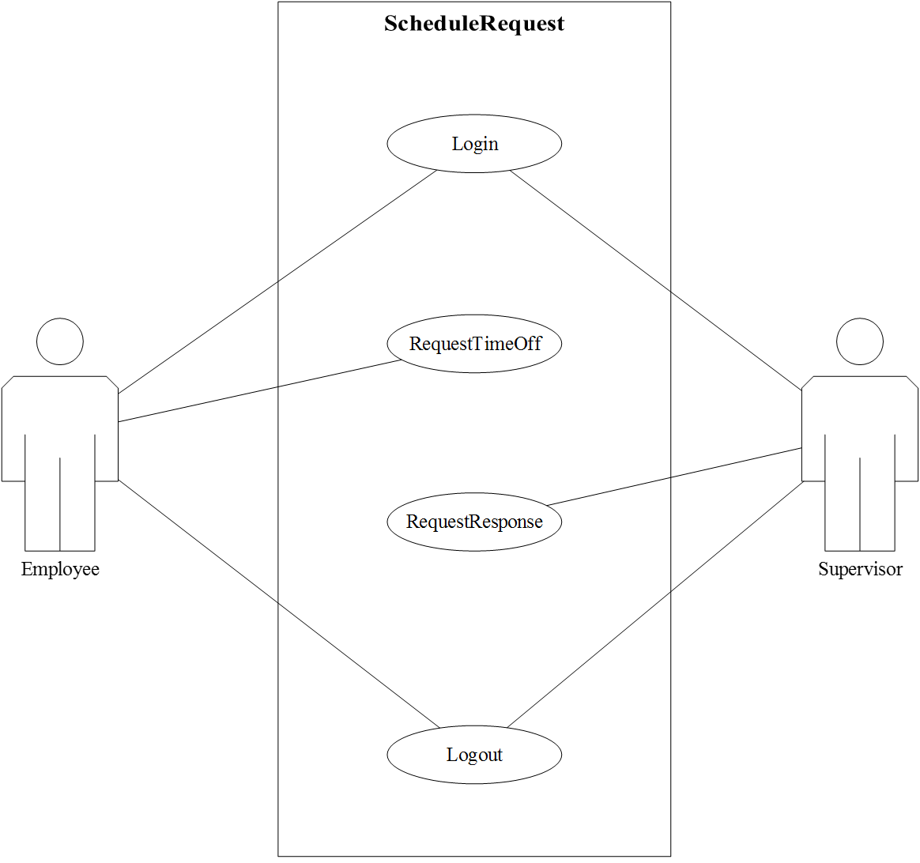

* 1. **Use Case Descriptions**

|  |  |
| --- | --- |
| *Use case name* | ValidLogin |
| *Participating actors* | Initiated by Employee |
| *Flow of events* | 1. Employee enters their EmployeeID and Password. 2. ESS responds by authenticating the entered EmployeeID and password. Upon authentication, ESS displays the appropriate interface. |
| *Entry condition* | The Employee enters their login information into ESS |
| *Exit condition* | The Employee entered properly authenticated credentials |
| *Security requirements* | All login credentials are hashed and stored server-side, allowing for a higher degree of information security. |

|  |  |
| --- | --- |
| *Use case name* | InvalidLogin |
| *Participating actors* | Initiated by **System** after invalid credential input by **Employee** or **Supervisor.** |
| *Flow of events* | 1. User supplies invalid credentials to the login interface.  2. **System handles the input, returning a user-specific error in a pop-up message/dialog box. A button is made available once control is passed back to the user.**  3. The user must acknowledge the button in the dialog/box in order to proceed.  4. **System returns the user to the login page, where the user is then able to try to enter valid credentials once more.** |
| *Entry condition* | A user enters invalid credentials. |
| *Exit condition* | The user acknowledges the invalid entry. |
| *Security requirements* | The password must be hashed at all times it is handled by InvalidLogin. The dialogue boxes that handle username and password must be shielded against code execution and SQL injections. Password policy must be used to eliminate malicious input. Windows shortcut-key exploits must be disabled to avoid accessing a shell or forcing an exploit. Only <ENTER> will be recognized for acknowledgement of the message/dialogue box. |

|  |  |
| --- | --- |
| *Use case name* | InvalidRequestTimeOff |
| *Participating actors* | Initiated by **Employee**, handled by **System** |
| *Flow of events* | 1. **Employee** is logged in and authorized. **Employee** enters one or more invalid parameters to the RequestTimeOff GUI interface or time/date text box (such as inappropriate or fabricated dates).  **2. System performs preliminary comparisons to avoid an exception. It then provides user-appropriate error message in the form of a dialogue box.**  3. **Employee** must acknowledge the error by responding to the dialogue box.  **4. System returns the user control once restoring the RequestTimeOff GUI page**. |
| *Entry condition* | **Employee** provides one or more invalid parameters to the calendar GUI or time/date text box. |
| *Exit condition* | **Employee** acknowledges the error from system. |
| *Security requirements* | The dialogue boxes that handle time and date must be shielded against code execution and SQL injections. Windows shortcut-key exploits must be disabled to avoid accessing a shell or forcing an exploit. Only <ENTER> will be recognized for acknowledgement of the message/dialogue box. |

|  |  |
| --- | --- |
| *Use case name* |  |
| *Participating actors* |  |
| *Flow of events* |  |
| *Entry condition* |  |
| *Exit condition* |  |
| *Security requirements* |  |

|  |  |
| --- | --- |
| *Use case name* | TimeOffResponse |
| *Participating actors* | Initiated by Supervisor |
| *Flow of events* | 1. ESS displays a queued notification alerting the Supervisor of the pending time off request. 2. Supervisor selects the appropriate request from their ESS interface and clicks either Approve or Deny. 3. ESS sends the resulting response to the originating Employee. |
| *Entry condition* | The Supervisor logs into their ESS account |
| *Exit condition* | The Supervisor submits a TimeOffResponse approval, OR the Supervisor submits a TimeOffResponse denial. |
| *Security requirements* | All responses are tracked by EmployeeID ensuring that no unauthorized individuals are able to surreptitiously gain access to a request. |

|  |  |
| --- | --- |
| *Use case name* |  |
| *Participating actors* |  |
| *Flow of events* |  |
| *Entry condition* |  |
| *Exit condition* |  |
| *Security requirements* |  |

|  |  |
| --- | --- |
| *Use case name* |  |
| *Participating actors* |  |
| *Flow of events* |  |
| *Entry condition* |  |
| *Exit condition* |  |
| *Security requirements* |  |

|  |  |
| --- | --- |
| *Use case name* |  |
| *Participating actors* |  |
| *Flow of events* |  |
| *Entry condition* |  |
| *Exit condition* |  |
| *Security requirements* |  |

|  |  |
| --- | --- |
| *Use case name* |  |
| *Participating actors* |  |
| *Flow of events* |  |
| *Entry condition* |  |
| *Exit condition* |  |
| *Security requirements* |  |

|  |  |
| --- | --- |
| *Use case name* |  |
| *Participating actors* |  |
| *Flow of events* |  |
| *Entry condition* |  |
| *Exit condition* |  |
| *Security requirements* |  |

|  |  |
| --- | --- |
| *Use case name* |  |
| *Participating actors* |  |
| *Flow of events* |  |
| *Entry condition* |  |
| *Exit condition* |  |
| *Security requirements* |  |